[Organisation] · PHASE D
Technology Reference Model
Sixteen technology purposes, and the five where the approved answer is out of support or does not exist
Field | Detail
Version | 0.1 — Draft
Date | October 2027
Owner | Technology Domain Architect
Approver | Architecture Board
Source | Components, standard status, vendor and support dates from metamodel O26 and O27. Platform services and consumption route from O28. Standards from O32. Purposes and guidance authored here.
Classification | Internal

1. How to use this
This is the approved technology list, and the counterpart to the Application Reference Model. A solution architect reads it at design; the Architecture Board reads it at G2.

Status | What it means | Derived from | Purposes
Current | The standard. Use it unless there is a reason not to, and record the reason. | On standard and inside vendor support. | 7 purposes
Emerging | The intended standard. Design to it; do not build on it yet. | Emerging standard status, or a product not yet selected. | 3 purposes
Contained | In use and not the standard. Keep what is there, add nothing new. | Contained standard status, still inside support. | 1 purpose
Unsupported | In use, past vendor support, and still carrying production. | Support end date in the past. | 3 purposes
No standard | No technology is approved for this purpose. | No component deployed, or no product selected. | 2 purposes

1.1 Five rules
Rule | What it means | Why
Use the Current technology by default | If a purpose has a Current answer, use it. | A deviation is an architecture decision, not a project preference. It goes to the Board with a stated reason.
Never build new on Unsupported or Contained | Unsupported means the vendor will not fix it. Contained means keep what exists. | Four purposes fall here. New workload on WebSphere or the MFT server is how a renewal date moves out another year.
Design to Emerging, build on Current | An emerging standard tells you the shape of the target. | The API gateway and the event streaming platform have no product selected. Design as if they will exist; integrate to what runs today.
A standard that is not in force cannot be cited | Ten of the sixteen technology standards are Emerging. | The rule against new point-to-point integration is one of them. It is right and it does not bind, which is why the estate looks as it does.
Where there is no standard, say so | Two purposes have no approved technology at all. | The honest answer is that the estate has no answer. Inventing one in a solution design is how a ninth unmasked platform appears.

Unsupported is a separate status from Contained, and the distinction matters
Contained means a decision has been taken not to extend a technology. Unsupported means the vendor will not fix it. Three purposes are served by unsupported technology, and fourteen applications sit on the runtime pair alone.

2. The reference model
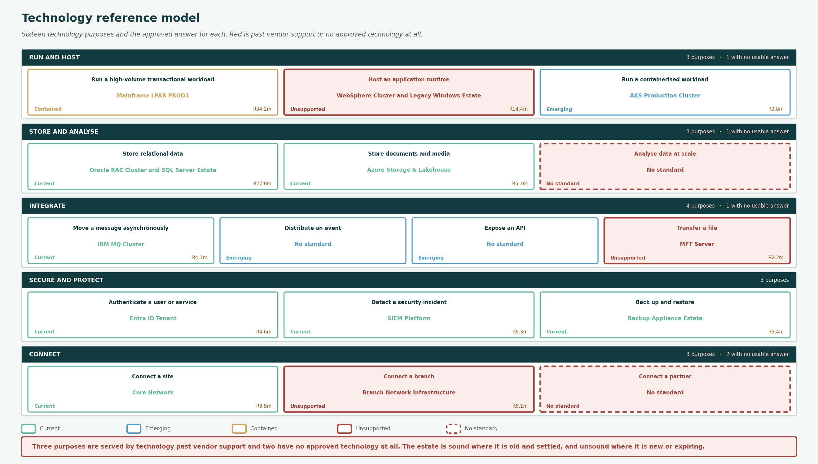
Sixteen purposes in five groups. Red is past vendor support or no approved technology at all.

3. Purpose by purpose

Run a high-volume transactional workload
Online transaction processing at scale.
Standard today | Mainframe LPAR PROD1 (Contained) · R34.2m a year
At target | Undecided
When to use it | Only what is already there. R34.2m a year, thirty-eight months of support remaining.
When not to | No new workload. Contained is a standards decision and the platform has runway, so this is not urgent and it is not reversible either.

Host an application runtime
Somewhere for application code to execute.
Standard today | WebSphere Cluster and Legacy Windows Estate (Unsupported) · R14.4m a year
At target | AKS Production Cluster
When to use it | Nothing. Both components passed vendor support in September and October 2027.
When not to | Seven applications sit on each. The replacement is the container platform, which is Emerging and carries three applications.

Run a containerised workload
Scheduling and lifecycle of containers.
Standard today | AKS Production Cluster (Emerging) · R3.8m a year
At target | AKS Production Cluster
When to use it | New workloads designed for containers. Self-service through the Managed Runtime Platform.
When not to | Not yet for the seven applications on WebSphere. The migration is not funded.

Store relational data
Durable transactional persistence.
Standard today | Oracle RAC Cluster and SQL Server Estate (Current) · R27.8m a year
At target | Same
When to use it | Everything relational. Self-service through the Managed Database Platform, the oldest self-service route in the estate.
When not to | Not for analytical query at scale. Each carries ten critical dependants, so the recovery tier of the platform is the recovery tier of ten applications.

Store documents and media
Durable object storage.
Standard today | Azure Storage & Lakehouse (Current) · R5.2m a year
At target | Same
When to use it | All correspondence, policy documents and media. Self-service through the Content Platform.
When not to | It stores and nothing removes. Retention is recorded per document type and enforced by nothing.

Analyse data at scale
Elastic compute for analytical and model workloads.
Standard today | No standard (No standard)
At target | Lakehouse Platform
When to use it | Nothing. The lakehouse platform is Emerging and has no deployed component.
When not to | Two applications already record a critical dependency on a service with nothing behind it.

Move a message asynchronously
Guaranteed asynchronous delivery.
Standard today | IBM MQ Cluster (Current) · R4.1m a year
At target | IBM MQ, then event streaming
When to use it | Existing asynchronous integration. Four applications, three critically.
When not to | Not for event distribution, which is a different pattern. No new point-to-point queue.

Distribute an event
Publish and subscribe event distribution.
Standard today | No standard (Emerging)
At target | Event Streaming Cluster
When to use it | Nothing. No product has been selected.
When not to | Until it is selected, an event-driven design has nowhere to run. Say so in the design rather than assuming.

Expose an API
Publication, versioning, throttling and security.
Standard today | No standard (Emerging)
At target | API Gateway Platform
When to use it | Nothing. No product has been selected, and the component is recorded at R0.
When not to | Forty-four of fifty interfaces are unmanaged because there is nowhere managed to put them. A new interface today is a point-to-point one; record it rather than hide it.

Transfer a file
Scheduled and secure file exchange.
Standard today | MFT Server (Unsupported) · R2.2m a year
At target | Event streaming, or a managed transfer service
When to use it | Nothing new. Vendor support ended in June 2027 and it still moves batch files between LIFE/400 and the finance estate.
When not to | Twenty batch files exist in the estate. Each one is a customer-visible delay, and this is the platform carrying them.

Authenticate a user or service
Authentication, authorisation and access review.
Standard today | Entra ID Tenant (Current) · R4.6m a year
At target | Same
When to use it | All authentication. Self-service through the Identity Platform, rolling cloud support.
When not to | It does not deliver named-individual access to Restricted data or periodic access review. STD-06 is in breach and GAP-17 is open.

Detect a security incident
Detection, logging and incident response.
Standard today | SIEM Platform (Current) · R6.3m a year
At target | Same
When to use it | All detection and log aggregation. Self-service through the Observability Platform.
When not to | It does not cover interface traffic. Forty-four of fifty interfaces are unmanaged and log nothing, which is why STD-11 is in breach.

Back up and restore
Data protection and restoration to a defined objective.
Standard today | Backup Appliance Estate (Current) · R5.4m a year
At target | Same
When to use it | All backup. Managed on request rather than self-service.
When not to | It does not deliver a recovery objective you can rely on. GAP-16 records the resilience tiers as never tested.

Connect a site
Wide-area connectivity between [Organisation] locations.
Standard today | Core Network (Current) · R8.9m a year
At target | Same
When to use it | All inter-site connectivity. Four applications depend on it critically.
When not to | The branch half of this service is a separate component with eight months of support and no renewal work package.

Connect a branch
Connectivity to the branch estate.
Standard today | Branch Network Infrastructure (Unsupported) · R6.1m a year
At target | Undecided
When to use it | Nothing new. Support ends June 2028, which is inside the procurement lead time for a network refresh.
When not to | One record stands for the entire branch estate. How many branches and what each contains is not recorded, so a renewal is a procurement against an unknown quantity.

Connect a partner
Connectivity to brokers, bancassurance and funeral parlours.
Standard today | No standard (No standard)
At target | API Gateway Platform
When to use it | Nothing approved. 3,400 brokerages, a bancassurance partner and more than 3,000 funeral parlours connect somewhere.
When not to | No link, zone or control is recorded for any external party. Two external actors reach Restricted data and the route is not modelled.

4. The components behind it
What each approved technology actually is, read from the repository.

Purpose | Status | Ref | Component | Vendor and product | Support ends | Cost Rm
Run a high-volume transactional workload | Contained | PTC-01 | Mainframe LPAR PROD1 | IBM z/OS with CICS | 2030-12 | 34.2
Host an application runtime | Unsupported | PTC-03 | WebSphere Cluster | IBM WebSphere | 2027-09 | 6.8
 |  | PTC-07 | Legacy Windows Estate | VMware vSphere | 2027-10 | 7.6
Run a containerised workload | Emerging | PTC-09 | AKS Production Cluster | Azure Kubernetes Service | rolling | 3.8
Store relational data | Current | PTC-04 | Oracle RAC Cluster | Oracle Database | 2032-04 | 18.6
 |  | PTC-05 | SQL Server Estate | Microsoft SQL Server | 2030-01 | 9.2
Store documents and media | Current | PTC-10 | Azure Storage & Lakehouse | Azure Storage / Delta | rolling | 5.2
Analyse data at scale | No standard | — | nothing deployed | — | — | —
Move a message asynchronously | Current | PTC-08 | IBM MQ Cluster | IBM MQ | 2029-06 | 4.1
Distribute an event | Emerging | — | nothing deployed | — | — | —
Expose an API | Emerging | — | nothing deployed | — | — | —
Transfer a file | Unsupported | PTC-15 | MFT Server | Managed file transfer suite | 2027-06 | 2.2
Authenticate a user or service | Current | PTC-11 | Entra ID Tenant | Microsoft Entra ID | rolling | 4.6
Detect a security incident | Current | PTC-12 | SIEM Platform | Commercial SIEM | rolling | 6.3
Back up and restore | Current | PTC-13 | Backup Appliance Estate | Enterprise backup suite | 2029-03 | 5.4
Connect a site | Current | PTC-14 | Core Network | Enterprise switching and routing | 2029-12 | 8.9
Connect a branch | Unsupported | PTC-18 | Branch Network Infrastructure | Enterprise branch stack | 2028-06 | 6.1
Connect a partner | No standard | — | nothing deployed | — | — | —

5. Findings
Three purposes are served by technology past vendor support
Hosting an application runtime, transferring a file and connecting a branch. WebSphere and the Legacy Windows Estate passed support in September and October; the MFT server in June.
Unsupported is worse than Contained and the model distinguishes them. Contained means a decision has been taken not to extend; unsupported means the vendor will not fix it. Fourteen applications sit on the runtime pair alone.
Two purposes have no approved technology at all
Analysing data at scale, and connecting a partner.
Analytics has a target with nothing deployed and two applications already depending on it critically. Partner connectivity has nothing at all: 3,400 brokerages connect by a route no artifact records, and two external actors reach Restricted data through it.
Three more have a target named and no product selected
Exposing an API, distributing an event, and by extension any event-driven design.
The API gateway is why forty-four of fifty interfaces are unmanaged. There is nowhere managed to put an interface, so every new one is point-to-point and the standard forbidding that is Emerging.
Seven of sixteen purposes have a Current answer and they are the boring ones
Relational storage, object storage, messaging, identity, detection, backup and site connectivity.
The estate is sound where it is old and settled, and unsound where it is new or expiring. That is the opposite of the usual story and worth saying plainly, because it changes where the money should go.
The reference model is authored and the repository holds none of it
Sixteen purposes, five status values and the guidance against each. The metamodel records components, standards and support dates, not what anyone should pick.
Same gap the Application Reference Model found on its side. Both should go into the repository, and a reference model kept in a deck is one nobody checks against at a design review.

Referenced artifacts
- Application Reference Model · Technology Architecture · Technology Portfolio Catalogue
- Technology Standards · Technology Service Catalog · Platform Decomposition
- Metamodel O25 to O28 and O32. The reference model itself is not held in the repository; raised as CR-044.

